Why We Recommend Pet Supplements with the NASC Quality Seal
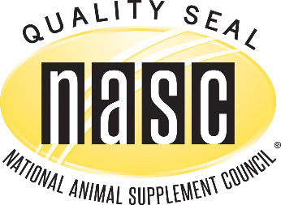
The pet supplement market has grown tremendously over the past several years. From joint support and probiotics to calming supplements, omega-3 fatty acids, and immune support, there are hundreds of products available. Unfortunately, not all supplements are manufactured to the same standards.

At Pathway Veterinary Services, we recommend choosing supplements that display the National Animal Supplement Council (NASC) Quality Seal whenever possible.

What is the NASC?
The National Animal Supplement Council (NASC) is a nonprofit organization dedicated to improving the quality, safety, and integrity of animal health supplements. The NASC works with manufacturers to establish rigorous quality standards designed to give veterinarians and pet owners greater confidence in the products they purchase.

What Does the NASC Quality Seal Mean?
A supplement displaying the yellow NASC Quality Seal has been manufactured by a company that has successfully completed an independent third-party quality audit and continues to meet strict ongoing standards. These companies must:
- Maintain detailed quality control procedures and manufacturing standards.
- Follow stringent labeling requirements.
- Have a system for tracking and investigating adverse events or customer complaints.
- Submit to random independent laboratory testing to verify that products contain what their labels claim.
- Participate in continuing education and maintain ongoing compliance with NASC quality requirements.

Why This Matters for Your Pet
Unlike prescription medications, many pet supplements do not undergo the same FDA approval process before reaching the marketplace. That makes selecting a reputable manufacturer especially important.
Choosing a supplement with the NASC Quality Seal helps increase confidence that:
- The ingredients listed on the label are actually in the product.
- The supplement is manufactured under established quality control procedures.
- The company is committed to transparency and ongoing product monitoring.
- Manufacturing practices are routinely evaluated by an independent third party.
While no certification can guarantee that every supplement will work for every pet, the NASC Quality Seal is one of the strongest indicators that a manufacturer is committed to producing consistent, high-quality products.

Our Recommendation
When considering a supplement for your dog or cat, ask your veterinarian which product is most appropriate for your pet's specific condition. Whenever possible, choose products from manufacturers that have earned the NASC Quality Seal.
To view the complete list of NASC member companies and products that have earned permission to display the Quality Seal, visit:
NASC Audited Member Companies & Quality Seal Products
Your pet deserves products that are backed by quality, consistency, and accountability. Choosing supplements with the NASC Quality Seal is one simple step you can take to help ensure you're giving your companion the safest, highest-quality nutritional support available.

