Why We Recommend Products with the VOHC® Seal
When it comes to your pet's dental health, not all dental treats, chews, toothpastes, water additives, and diets are created equal. Many products make claims about reducing plaque or freshening breath, but only a select group have been scientifically proven to do so. That's why we recommend choosing products that carry the Veterinary Oral Health Council (VOHC®) Seal of Acceptance whenever possible.

What is the VOHC®?
The Veterinary Oral Health Council (VOHC®) is an independent organization made up of board-certified veterinary dentists and dental scientists. Their role is to review scientific research submitted by manufacturers to determine whether a product has been shown to effectively reduce plaque, tartar (calculus), or both when used as directed.

Look for the VOHC® Seal
When shopping for dental products, look for the VOHC® Seal of Acceptance on the product packaging. This seal indicates that the product has met the Veterinary Oral Health Council's standards for reducing plaque, tartar (calculus), or both when used as directed.
Examples of the official VOHC® Seals:
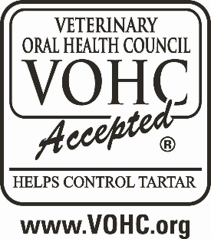
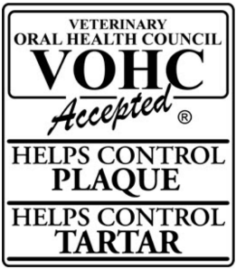
Tip: If a dental product does not display the VOHC® Seal, it doesn't necessarily mean the product is ineffective. It simply means the product has not earned the VOHC® Seal of Acceptance through the organization's scientific review process. Choosing a VOHC-approved product gives you confidence that its dental claims have been independently reviewed and supported by scientific evidence.

Our Recommendation
When shopping for your pet's dental products, look for the VOHC® Seal of Acceptance on the packaging. Whether you're choosing a dental chew, prescription dental diet, toothpaste, water additive, or oral rinse, selecting a VOHC-approved product helps ensure you're using something that has been proven to work.
To view the current list of approved products for both dogs and cats, visit the official VOHC® Accepted Products page:
https://vohc.org/accepted-products/
At Pathway Veterinary Services, we believe that healthy teeth contribute to a happier, healthier life. Choosing products with the VOHC® Seal is one simple step you can take to help protect your pet's smile for years to come.

